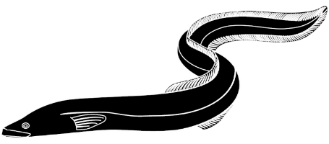

[Date]
[Your name]
[Your school]
[Your address]

Tēnā koe,
I am concerned about the health and wellbeing of tuna and our local waterway.
I visited [insert name of local waterway] to check on the health of the waterway after learning about how the things we do on land and in our awa can have a negative impact on freshwater fisheries like tuna and their habitat. As part of my visit, I scored the waterway based on indicators of health like tree coverage, riverbed and human impact.
[insert name of local waterway] scored X/X which means it is in a [poor/very poor/ok/fair] state. I have included my awa health check with this letter. Two reasons it received this score are:

We ask that you please address these issues for our awa. Please consider the health and wellbeing of the tuna and awa, they are special, and we need to look after them.

Ngā mihi,

[Insert name]
[insert school name]

